DEPI GRADUATION PROJECT | ROUND 4
Jumia Clone
E-Commerce Web Application
Project Documentation
Project Planning • Stakeholder Analysis • Database Design • UI/UX Design
Prepared By
Raghda Soliman Mohamed Ahmed
Eman Mahfouz Korny Mahmoud
Menna Allah Hossam Mohamed Tawfik
Zeinab Ahmed Mohamed Mohamed
Basmala Saleh Abdelhalim Abdelkarim
Salsabil Mohamed Abdelrhman Ramadan
Supervised By: Maged Samir

Table of Contents
1. Project Planning
1.1 Project Overview
1.2 Project Objectives
1.3 Project Scope
1.4 Problem Statement
1.5 Development Methodology
1.6 Tools and Technology Stack
1.7 Risks and Mitigation
2. Stakeholder Analysis
2.1 Stakeholder Overview
2.2 Stakeholder Interest vs. Influence
2.3 Roles Within the Development Team
3. Database Design
3.1 Overview
3.2 Main Entities
3.3 Key Relationships
3.4 Entity Relationship Diagram (ERD)
3.5 Architecture Layers
3.6 API Modules
4. UI/UX Design
4.1 Design Goals
4.2 Visual Identity
4.3 Key Screens
4.4 UX Principles Applied
4.5 Sample Screens

1. Project Planning

1.1 Project Overview
The project is a full-stack e-commerce platform inspired by Jumia, developed as a graduation project for DEPI (Digital Egypt Pioneers Initiative) — Round 4. The system consists of a client-side frontend (HTML, CSS, JavaScript) and an ASP.NET Core Web API backend, backed by a relational database managed through Entity Framework Core.
The platform allows customers to browse products, search and filter by category, manage a shopping cart and wishlist, checkout, track orders, and leave product reviews, while administrators can manage the product catalog, categories, brands, and orders through the same API.

1.2 Project Objectives

Main Goal
- Develop a full-stack e-commerce platform inspired by Jumia, demonstrating end-to-end web development skills covering frontend, backend, database, and API integration.

Supporting Objectives
- Deliver a user-friendly, intuitive shopping experience.
- Implement secure authentication and authorization (JWT-based, with two-factor verification).
- Provide efficient product, category, brand, and order management for administrators.
- Build a responsive user interface that works across devices.
- Design and expose a RESTful API for all core e-commerce operations.
- Maintain a reliable, well-structured relational database.

1.3 Project Scope

In Scope
- Customer registration, login, and two-factor authentication.
- Product catalog browsing, searching, and filtering by category/brand.
- Shopping cart (basket) and wishlist management.
- Checkout flow with shipping address and delivery method selection.
- Order placement, order history, and order details.
- Product reviews and ratings.
- An AI-assisted chat bot for customer support/product inquiries.
- Administrative management of products, categories, brands, and orders via the API.

Out of Scope (current version)
- Online payment gateway integration (payment is simulated/handled at a later phase).
- A dedicated admin-facing frontend UI (administration currently relies on direct API access).
- Multi-vendor / marketplace seller management.

1.4 Problem Statement

Problem
- Difficulty finding products quickly.
- Complex and time-consuming shopping process.
- Security concerns during login and account management.
- Limited tools for managing orders and products efficiently.

Solution
- Fast product browsing and searching.
- Secure user authentication and authorization.
- Shopping cart and wishlist functionality.
- Efficient order and product management.
- Responsive and user-friendly interface across devices.

1.5 Development Methodology
The team followed an iterative, Agile-inspired approach, splitting the work into short cycles that progressively delivered a working increment of the system — from data modelling, to core API endpoints, to full frontend integration.
Phase | Focus | Key Outputs
Phase 1 — Planning & Design | Requirements gathering, stakeholder analysis, database design (ERD), UI wireframing | Domain model, ERD, low-fidelity UI mockups
Phase 2 — Backend Foundation | Project setup, Identity/Auth, EF Core + database migrations | AppDbContext, Identity tables, JWT authentication
Phase 3 — Core API Development | Products, Categories, Brands, Basket, Wishlist APIs | RESTful endpoints, DTOs, validation
Phase 4 — Orders & Extended Features | Orders, Reviews, Delivery methods, Chat bot API | Checkout flow, order tracking, review system
Phase 5 — Frontend Development | Static pages (home, category pages, product details, cart, checkout, account) | Responsive HTML/CSS/JS interface
Phase 6 — Integration & Testing | Connecting frontend to the Web API, error handling, validation | Fully integrated application
Phase 7 — Deployment & Presentation | Final testing, demo preparation, documentation | Live demo, final presentation

1.6 Tools and Technology Stack
Layer | Technology
Backend Framework | ASP.NET Core Web API (.NET)
ORM / Data Access | Entity Framework Core (Code-First Migrations)
Authentication | ASP.NET Core Identity, JWT Bearer Tokens, Two-Factor Verification
Database | SQL Server (relational database)
Frontend | HTML5, CSS3, JavaScript
API Testing | Jumia.http (REST Client) / Postman
Version Control & Collaboration | Git & GitHub
Architecture Style | Layered architecture (Domain, Infrastructure, API/Controllers, DTOs)

1.7 Risks and Mitigation
Risk | Impact | Mitigation
Complex database relationships (users, orders, baskets, wishlists) | Medium | Careful ERD design early in the project before coding began
Securing authentication and user data | High | Used ASP.NET Identity + JWT + 2FA verification instead of custom auth logic
Frontend/Backend integration issues (CORS, data shape mismatches) | Medium | Defined clear DTOs and a shared configuration file (config.js) for API base URL
Team collaboration conflicts on GitHub | Medium | Feature branches, task division, and regular merges
Time constraints of the DEPI program schedule | Medium | Phased delivery plan with weekly milestones

2. Stakeholder Analysis
Identifying stakeholders early helped the team understand whose needs the system had to satisfy, and how to prioritize features such as authentication, product browsing, and order management.

2.1 Stakeholder Overview
Stakeholder | Category | Interest / Needs | Influence on Project
Customers (End Users) | Primary / External | Fast, easy, secure shopping experience: browsing, cart, checkout, order tracking, reviews | High — core requirements are driven by their needs
Administrators | Primary / Internal | Efficient tools to manage products, categories, brands, and orders | High — defines the management-side API requirements
Development Team | Primary / Internal | Clear requirements, manageable scope, learning full-stack development | High — responsible for design & delivery
Project Supervisor (Maged Samir) | Secondary / Internal | Technical guidance, quality assurance, adherence to best practices | High — approves direction and evaluates deliverables
DEPI Program (Digital Egypt Pioneers Initiative) | Secondary / External | Successful graduation project demonstrating applied skills | Medium — sets program requirements and evaluation criteria
Future Business Owners / Investors | Tertiary / External | A scalable, demonstrable e-commerce platform for potential real-world use | Low (at this stage) — potential long-term stakeholder
Payment / Delivery Partners (future integration) | Tertiary / External | Reliable integration points for payments and shipping | Low (currently out of scope)

2.2 Stakeholder Interest vs. Influence
The matrix below summarizes how the team prioritized engagement with each stakeholder group.
Quadrant | Stakeholders | Engagement Strategy
High Interest / High Influence | Customers, Administrators, Development Team, Project Supervisor | Manage closely — gather continuous feedback, involve in every major decision (features, UI, database design)
High Interest / Low Influence | Future Business Owners / Investors | Keep informed — document the platform's capabilities and scalability
Low Interest / High Influence | DEPI Program | Keep satisfied — comply with program milestones and evaluation criteria
Low Interest / Low Influence | Payment / Delivery Partners (future) | Monitor — revisit once payment/shipping integration becomes in-scope

2.3 Roles Within the Development Team
Team members collaborated across backend (ASP.NET Core Web API, database design) and frontend (HTML/CSS/JS interface) responsibilities, with shared ownership of integration and testing, coordinated through GitHub.
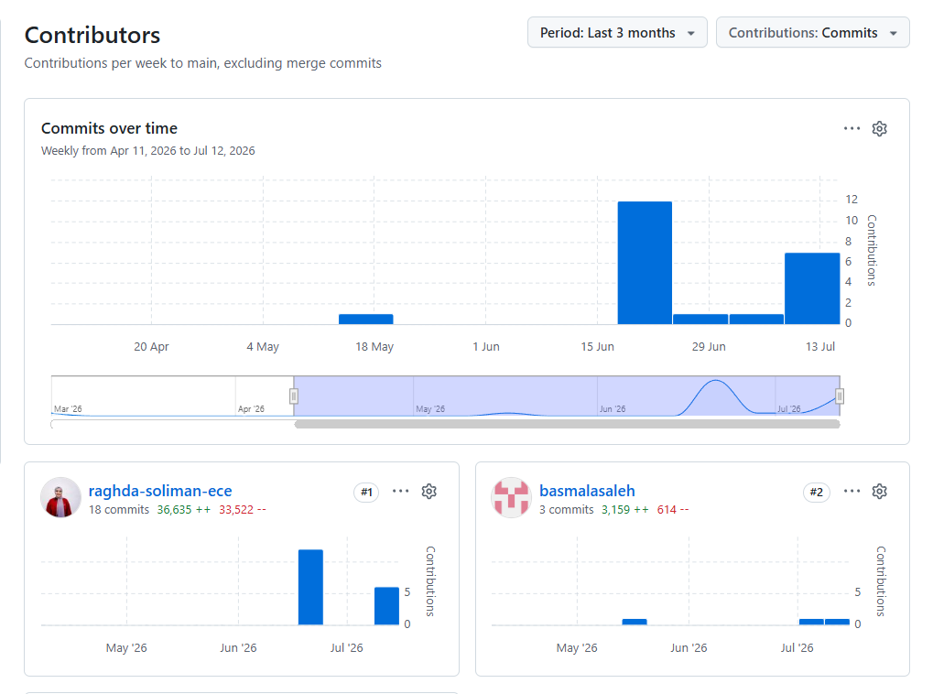
3. Database Design

3.1 Overview
The database follows a relational, normalized design managed with Entity Framework Core (Code-First). It combines ASP.NET Core Identity tables (for users, roles, and authentication) with domain-specific tables for the e-commerce catalog, shopping, and ordering workflow.

3.2 Main Entities
Entity | Purpose
AppUser | Extends ASP.NET Identity user with DisplayName and Address; central entity linked to baskets, orders, reviews, wishlist, and refresh tokens
Category | Product categories, supports a self-referencing parent/sub-category hierarchy
Brand | Product brands
Product | Core catalog entity: name, description, price, old price, stock, images, category & brand references
ProductImage | Additional images per product, with a flag for the main image
Basket / BasketItem | A user's active shopping cart and the line items inside it
WishlistItem | Products a user has saved for later
Order / OrderItem | A placed order and its line items (snapshot of product name/price at order time)
ShippingAddress | Delivery address associated with a single order
DeliveryMethod | Available shipping options and their price/duration
Review | Customer ratings and comments on products
RefreshToken | JWT refresh tokens issued per user for session renewal

3.3 Key Relationships
- One Category → Many Products (and a Category may have Sub-Categories)
- One Brand → Many Products
- One User → One Basket
- One Basket → Many Basket Items, One Product → Many Basket Items
- One User → Many Orders; One Delivery Method → Many Orders
- One Order → Many Order Items; One Order → One Shipping Address
- One Product → Many Reviews; One User → Many Reviews
- One User → Many Wishlist Items; One Product → Many Wishlist Items
- One Product → Many Product Images
- One User → Many Refresh Tokens

3.4 Entity Relationship Diagram (ERD)
The diagram below is the team's original ERD (Chen notation), showing entities, attributes, and relationship cardinalities as designed during the planning phase.
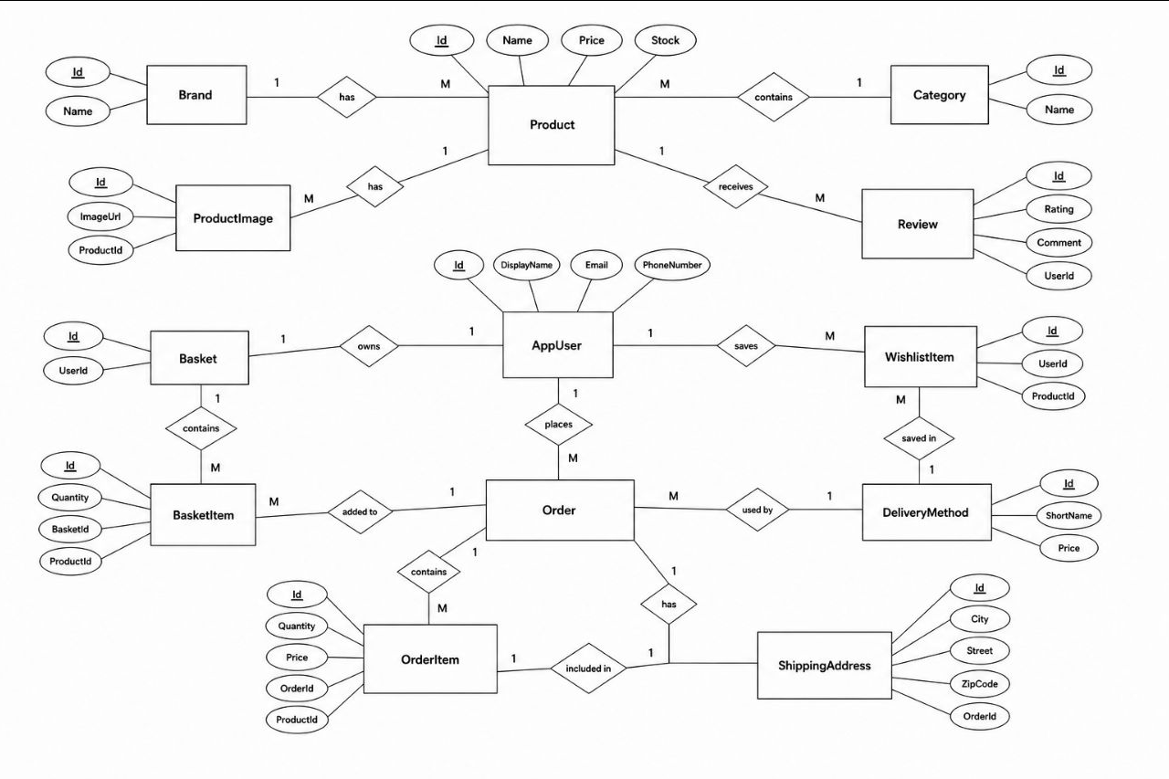

3.5 Architecture Layers
Layer | Responsibility
Jumia.Domain | Plain domain models (entities) — Product, Order, Category, AppUser, etc.
Jumia.Infrastructure | AppDbContext (EF Core), DbSeeder (initial data), schema.sql, migrations
Controllers | API endpoints exposing the domain through HTTP (Products, Orders, Basket, Auth, etc.)
DTOs | Data Transfer Objects shaping request/response payloads independently of domain models

3.6 API Modules (built on top of the database)
Module | Key Endpoints
Authentication API | Register, Login, Verify Two-Factor, Resend Two-Factor, Get Current User
Products API | Get Products (list/filter), Get Product by Id, Create, Update, Delete
Categories API | Get Categories, Get Category by Id, Create, Update, Delete
Brands API | Get Brands, Get Brand by Id, Create, Update, Delete
Basket API | Get Basket, Add/Update Item, Remove Item, Clear Basket
Wishlist API | Get Wishlist, Add to Wishlist, Remove from Wishlist
Orders API | Create Order, Get User Orders, Get Order Details, Get Delivery Methods
Reviews API | Get Product Reviews, Create Review
Chat API | Ask (chat bot query), Get Suggestions

4. UI/UX Design

4.1 Design Goals
- Deliver a shopping experience that feels familiar to Jumia users, reducing the learning curve.
- Keep navigation simple: category browsing, search, and account/cart access always reachable from the header.
- Ensure a fully responsive layout that adapts across desktop, tablet, and mobile.
- Use consistent visual language (color, typography, spacing) across all pages.

4.2 Visual Identity
The interface reuses Jumia's recognizable orange-and-dark color scheme to keep the shopping experience visually familiar.
Token | Value | Usage
Primary (Orange) | #F68B1E | Primary buttons, active states, highlights, prices
Primary Dark | #CC7218 | Hover/pressed states
Secondary (Dark) | #313133 | Header/footer, headings, primary text emphasis
Background | #F5F5F5 | Page background
Card Background | #FFFFFF | Product cards, panels, forms
Text | #333333 | Body copy
Muted Text | #75757A | Secondary/meta text
Border | #E0E0E0 | Card and input borders

4.3 Key Screens
Page | Purpose
Home (index.html) | Hero slider, featured categories (Electronics, Fashion, Mobiles, Home Appliances, Kids, Supermarket), promotional sections
Category Pages | Dedicated listing pages per category (electronics, fashion, mobiles, home-appliances, kids, supermarket) with filtering
Product Details (product-details.html) | Full product info, images, price, add-to-cart, add-to-wishlist, and customer reviews
Cart (cart.html) | Review basket items, adjust quantities, view subtotal before checkout
Checkout (checkout.html) | Shipping address entry, delivery method selection, order summary
Login (login.html) | Secure sign-in with two-factor verification support
Account (account.html) | User profile, order history, saved addresses
Chat Widget (chat-widget.js) | Floating assistant available across pages to help customers find products/answer questions

4.4 UX Principles Applied
- Consistency: shared header/footer and component styling (style.css) across every page.
- Feedback: clear states for cart updates, wishlist toggles, and form validation errors.
- Accessibility of information: prices, discounts (old price vs. new price), and stock/availability are always visible on product cards.
- Progressive disclosure: category pages show summarized product cards; full details are one click away on the product details page.
- Responsiveness: layout adapts using flexible CSS so the same pages work on mobile and desktop.

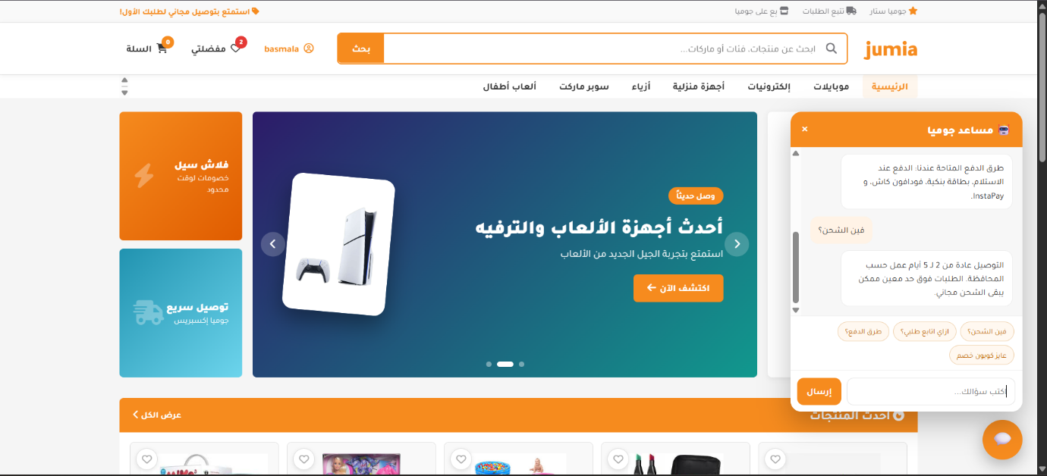
4.5 Sample Screens
